**Cloud Computing (Elastic Compute Cloud)**

Running Spring boot project on EC2 instance. We download or clone spring boot project from Git repository and we build and run the application.

1. Create spring boot project in local machine.
2. After development we need to push this project to git hub repository.
3. Then launch EC2 instance
4. install git
5. clone the project in EC2 instance
6. Install java software
7. Install maven software
8. mvn package create the jar file
9. Using java command run jar file.

**Installing git software in EC2 instance**

sudo yum install git -y

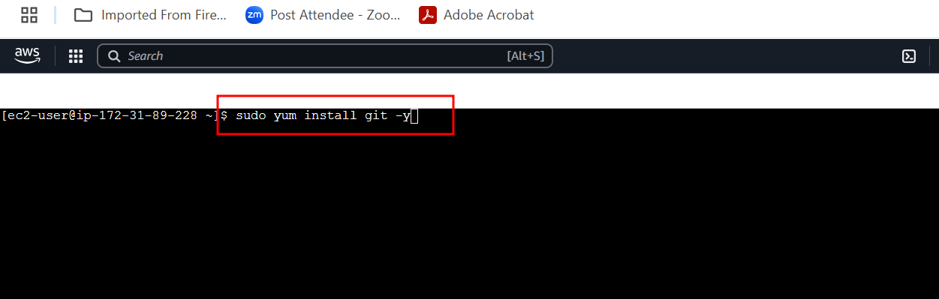

After git install please clone spring boot project from my repository / your repository

**git clone URL**

git clone <https://github.com/Kaleakash/spring_rest_api_caltech_batch.git>

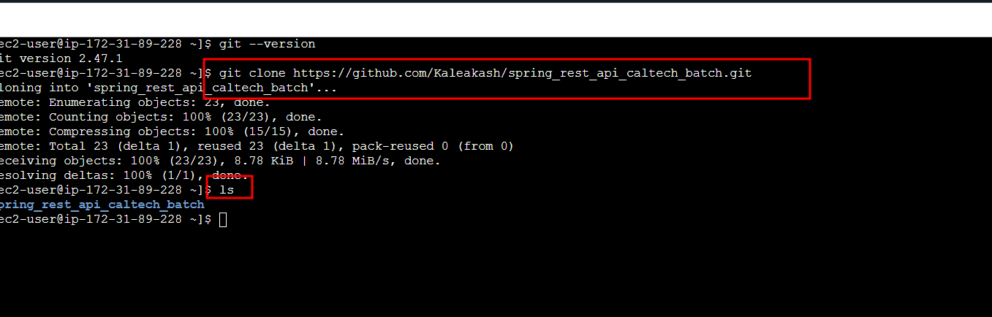

After clone please move inside a spring boot project folder

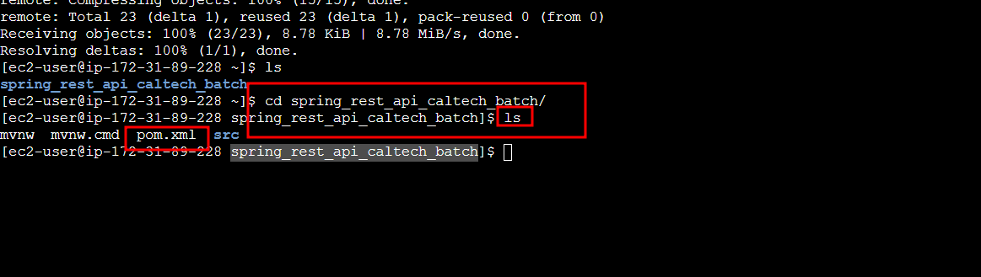

Now we will install java and maven software in EC2 instance machine.

Java must be 17.

sudo yum install java-17

Now install maven software

sudo yum install maven

to build the maven project (make sure you are inside a project folder (pom.xml file location).

**mvn package**

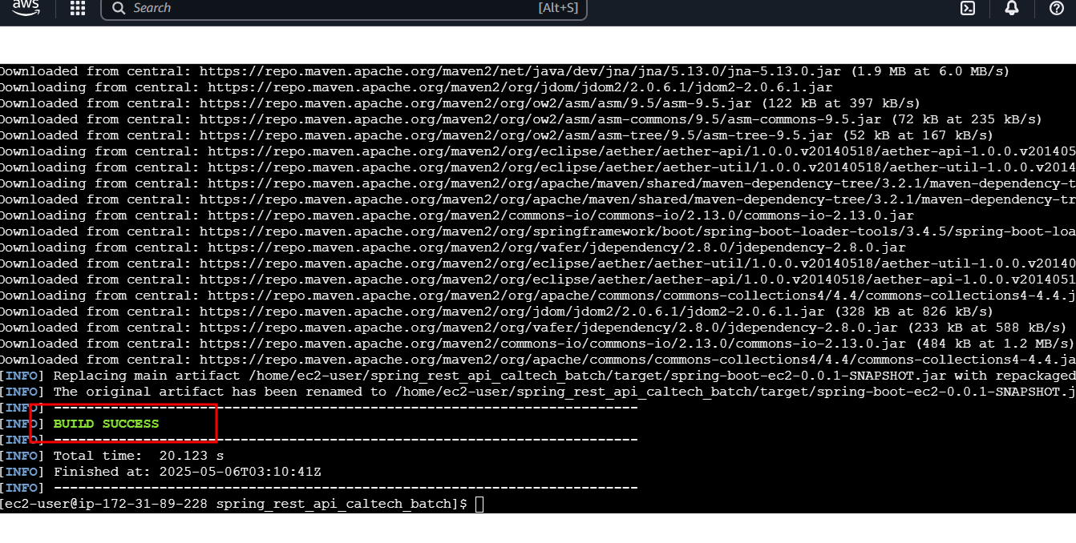

Please verify target folder created or not using ls command.

cd target

ls to verify jar file name

java -jar jarfilename.jar

